Full name: Edgar P. Esguerra Jr.

Screen Number: 1

Screen Name: Home

Screen Shot:

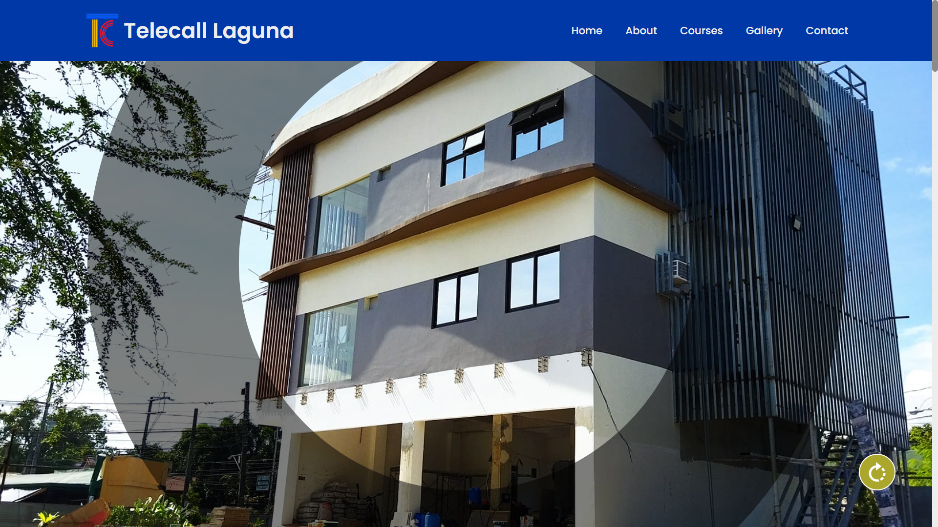

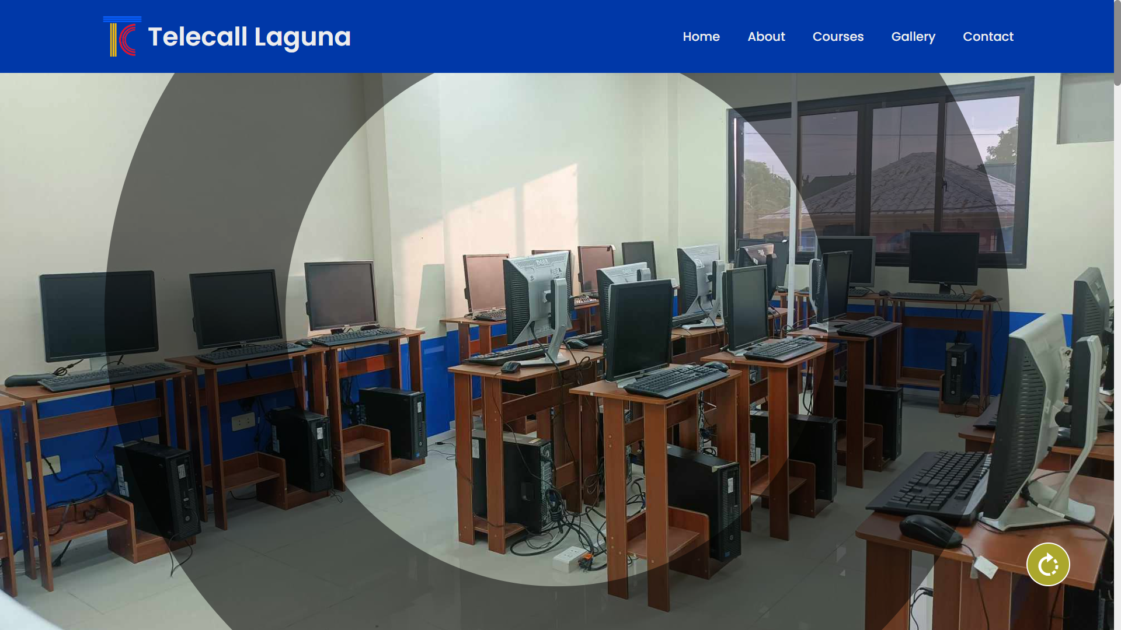

Narrative Overview:

This section contains the navigation bar (home, about, courses, gallery, contact as well as the logo). It has a special effect wherein when you click the rotate button, the background image will be changed.

Screen Number: 2

Screen Name: About

Screen Shot:



Narrative Overview:

This section contains information about the company including its mission and vision.

Screen Number: 3

Screen Name: Courses

Screen Shot:



Narrative Overview:

This section contains courses that are available from the company.

Screen Number: 4

Screen Name: Gallery

Screen Shot:

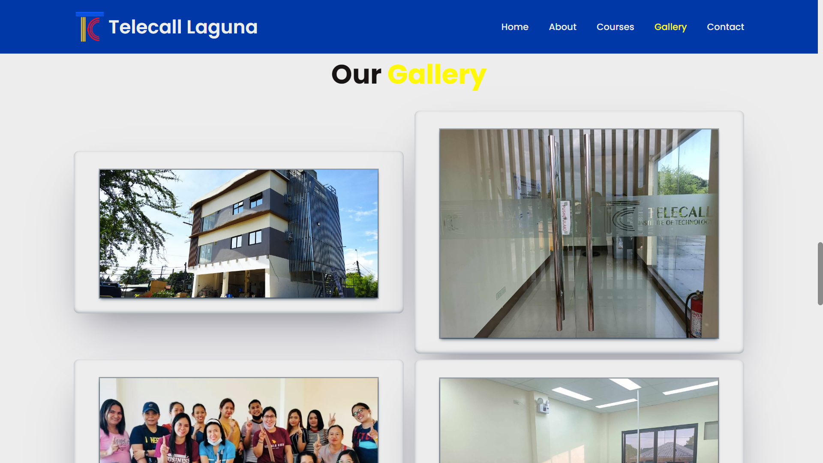

Narrative Overview:

This section contains pictures of the people as well as the place/building of the company.

Screen Number: 5

Screen Name: Contact

Screen Shot:



Narrative Overview:

This section contains a form wherein a user can input there message for the company.

Screen Number: 6

Screen Name: Footer

Screen Shot:

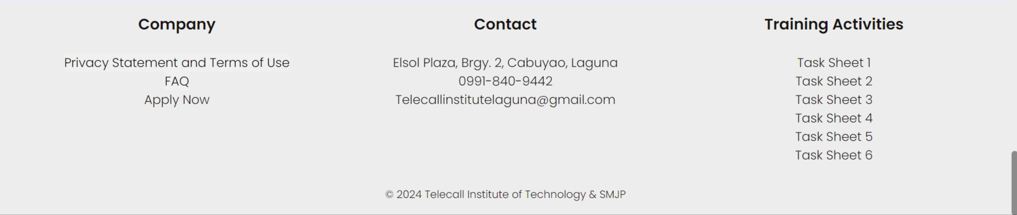

Narrative Overview:

This footer contains the company’s privacy statement and terms of use and frequently asked questions, contact information of the company as well the training activities of the student.

Screen Number: 7

Screen Name: Registration Form

Screen Shot:

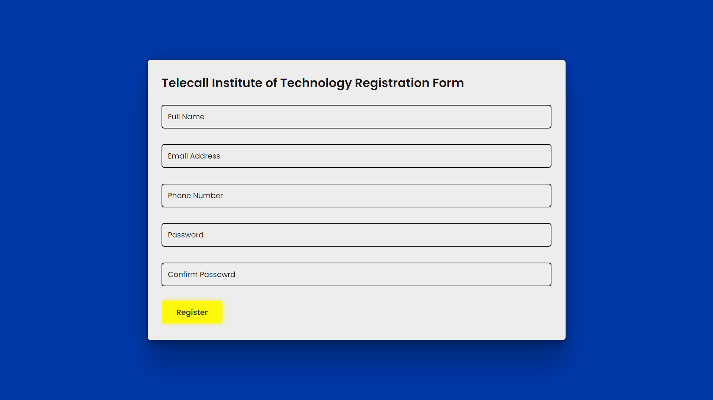

Narrative Overview:

This page contains the basic registration form.